Python CLI Shell Task
This week I created a simple Python command shell inspired by tutorials on building shells with Python and using the cmdstyle of interactive command processing. The shell supports four commands: LIST, ADD, HELP, and EXIT. The design follows a simple input loop, command parsing, and function-based handling, which matches the style shown in the Python shell tutorials by Praka and Szabo.

Example code
import os
def show_help():
"""Display the available commands."""
print("\nAvailable commands:")
print(" LIST - List files in the current directory")
print(" ADD x y - Add two numbers")
print(" HELP - Show this help message")
print(" EXIT - Exit the shell\n")
def list_directory():
"""List the contents of the current directory."""
print("\nCurrent directory contents:")
for item in os.listdir():
print("-", item)
print()
def add_numbers(parts):
"""Add two numbers entered after the ADD command."""
if len(parts) != 3:
print("Usage: ADD number1 number2\n")
return
try:
num1 = float(parts[1])
num2 = float(parts[2])
print(f"Result: {num1 + num2}\n")
except ValueError:
print("Error: please enter valid numbers.\n")
def main():
"""Run the interactive shell."""
print("Simple Python Shell")
print("Type HELP to see available commands.\n")
while True:
command = input("shell> ").strip()
parts = command.split()
if not parts:
continue
action = parts[0].upper()
if action == "LIST":
list_directory()
elif action == "ADD":
add_numbers(parts)
elif action == "HELP":
show_help()
elif action == "EXIT":
print("Exiting shell.")
break
else:
print("Unknown command. Type HELP for available commands.\n")
if __name__ == "__main__":
main()

Example test run

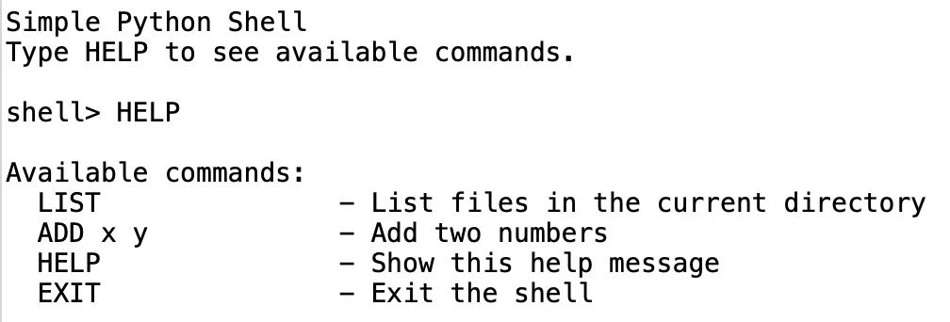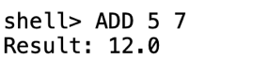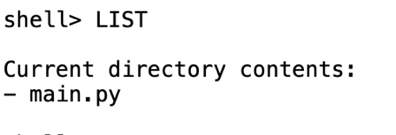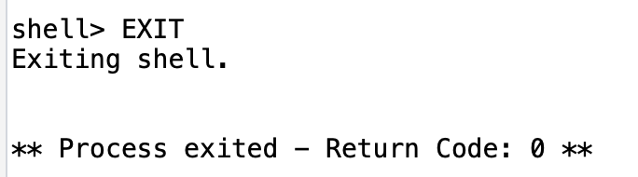

Reflection on security

Two main security vulnerabilities
- No authentication or access control
Anyone who can run the shell can use its commands. Even though this version is small, a larger shell could expose sensitive functions without restriction.
- Weak input handling
The shell accepts raw user input directly. While this version does not execute OS commands, poor input handling could become dangerous if expanded later, especially if commands were passed to os.system() or eval().

One recommendation to improve security
- Use strict input validation and an allowlist of commands
Only recognised commands should be accepted, and arguments should be checked for type, format, and length before processing.

Pseudocode for a more secure version
START shell
DEFINE allowed_commands = [LIST, ADD, HELP, EXIT]
LOOP until user exits
READ user input
TRIM whitespace
SPLIT input into command and arguments
IF command not in allowed_commands
PRINT "Invalid command"
CONTINUE
IF input length is too long
PRINT "Input rejected"
CONTINUE
IF command is ADD
CHECK there are exactly 2 arguments
CHECK both arguments are numeric
IF checks fail
PRINT "Invalid input"
CONTINUE
ELSE
PRINT sum
IF command is LIST
SHOW current directory contents safely
IF command is HELP
SHOW help
IF command is EXIT
TERMINATE shell
END LOOP

Conclusion
This task helped me understand how a shell can be built in Python using a simple command loop. It also showed that even a small CLI tool needs security thinking from the start, especially around input validation, command restrictions, and future extensibility. The tutorial sources were useful for understanding the interactive shell structure and command handling approach.

